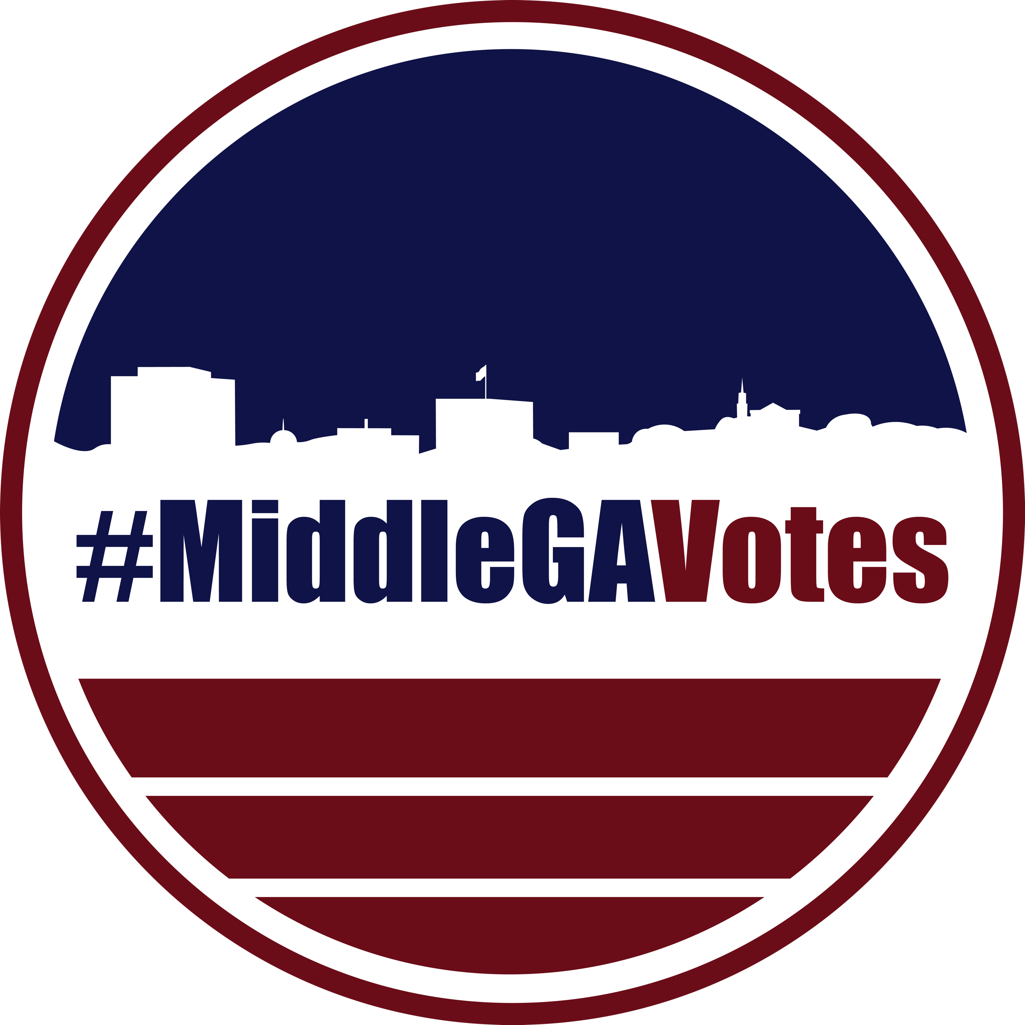
#MiddleGAVotes
P. O. Box 1704
Macon, Georgia 31209
MiddleGAVotes.org

FOR IMMEDIATE RELEASE
September 23, 2021

Contact: Marty Koplin
478-718-7001
middlegavotes@gmail.com

Non-Partisan Coalition Formed in Middle Georgia to Promote Voter Education

Macon-Bibb County, GA - Joined by the common ideal that the right to vote is essential to America’s democratic process, a coalition of Middle Georgia organizations has formed to promote voter education. The passing of Georgia’s SB 202 brought sweeping changes to our state’s voting process resulting in new challenges. These 14 organizations have come together to ensure that voters in Middle Georgia are aware of those changes and are ready to vote come election day.

“This is unprecedented to see the diversity represented in these groups joining together to raise a common voice about the sanctity of the vote.” said Lynn Snyder, co-president of Georgia Women (And Those Who Stand With Us).

Mary Lou Ezell, with the League of Women Voters, Macon Chapter said, “The League of Women Voters has fought for over a hundred years for the right to vote and still that right is being challenged. We see those rights infringed upon by limiting access and creating barriers. It’s time to stand up and fight to regain the right to vote for EVERYONE!”

Tisha Davis of Jack and Jill of America, Inc. Macon chapter echoed that sentiment, saying, “You have the power to make a difference!”

Other organizations that have joined this coalition are Macon (GA) Chapter of The Links, Incorporated, Macon Alumnae Chapter Delta Sigma Theta Sorority, Inc., #Middle Georgia Votes, Women of Unity, Macon, The Georgia Association of Black Women Attorneys, (Middle Georgia Chapter), Order of the Eastern Star, PHA, Georgia AKA Connection, The People’s Advocacy Group, Inc., The Macon Conference Women's Missionary Society, Macon Magazine and Alpha Rho Chapter of Lambda Kappa Mu Sorority, Inc.
The group will hold a press conference on Monday September 27 at 10:00 am at Rosa Parks Square in downtown Macon to announce the formation of the coalition and enumerate its goals.

###

